Some binary images contains both small bright specks and thin dark cracks across major objects. (CO3, CO4)
Design a sequence of morphological operations (dilation, erosion, opening, closing, or combinations) to:
remove small bright noise,
fill narrow dark cracks,
preserve the overall shape as much as possible.
Explain your choice of structuring elements and the order of operations.

1. Load the images and convert them to binary images
The images are the blob image, the portrait image and the fingerprint image of OPE 6. Bright (white) pixels are the foreground for the morphological operations.
Code:-
import cv2
import numpy as np
import matplotlib.pyplot as plt

# Function to show images in a row
def show(images, titles, size=(14, 4)):
plt.figure(figsize=size)
for i in range(len(images)):
plt.subplot(1, len(images), i + 1)
plt.imshow(images[i], cmap='gray', vmin=0, vmax=255)
plt.title(titles[i])
plt.axis('off')
plt.tight_layout()
plt.show()

# Load the images as grayscale
blob_gray = cv2.imread('blob.png', 0)
portrait_gray = cv2.imread('portrait.png', 0)
finger_gray = cv2.imread('fingerprint.png', 0)

# Convert to binary images (white = 255 is the bright part)
_, blob = cv2.threshold(blob_gray, 127, 255, cv2.THRESH_BINARY)
_, finger = cv2.threshold(finger_gray, 127, 255, cv2.THRESH_BINARY)
_, portrait = cv2.threshold(portrait_gray, 0, 255, cv2.THRESH_BINARY + cv2.THRESH_OTSU)

show([blob, portrait, finger], ['Blob (binary)', 'Portrait (Otsu binary)', 'Fingerprint (binary)'])

Output:-
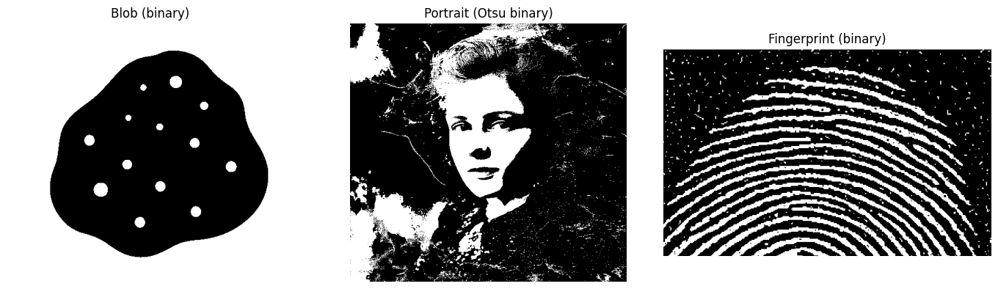

2. Measure the size of the specks, objects and cracks
The structuring element is chosen from these measurements.
Code:-
# Blob : size of the bright specks inside the dark object
n, labels, stats, _ = cv2.connectedComponentsWithStats(blob, connectivity=8)
background = stats[1:, cv2.CC_STAT_AREA].argmax() + 1 # the largest white region is the background
sizes = [max(stats[i, cv2.CC_STAT_WIDTH], stats[i, cv2.CC_STAT_HEIGHT]) for i in range(1, n) if i != background]
print("Blob : number of bright specks =", len(sizes), ", largest speck =", max(sizes), "pixels")

# Fingerprint : lengths of white runs (ridges) and black runs (gaps) along vertical lines
def run_lengths(line):
runs, value, count = [], line[0], 1
for v in line[1:]:
if v == value:
count += 1
else:
runs.append((value, count))
value, count = v, 1
runs.append((value, count))
return runs

white, black = [], []
for x in range(150, 450, 7):
for value, length in run_lengths((finger[200:380, x] > 0).astype(int)):
(white if value else black).append(length)

print("Fingerprint : median ridge width =", np.median(white), "pixels, median gap between ridges =", np.median(black), "pixels")
print("Fingerprint : white runs of 1-2 pixels =", sum(w <= 2 for w in white), ", black runs (cracks) of 1-2 pixels =", sum(b <= 2 for b in black))

n, labels, stats, _ = cv2.connectedComponentsWithStats(finger, connectivity=8)
speck = [max(stats[i, cv2.CC_STAT_WIDTH], stats[i, cv2.CC_STAT_HEIGHT]) for i in range(1, n) if stats[i, cv2.CC_STAT_AREA] <= 30]
print("Fingerprint : number of small bright specks =", len(speck), ", most of them are", np.bincount(speck).argmax(), "pixels wide")

Output:-
Blob : number of bright specks = 13 , largest speck = 26 pixels
Fingerprint : median ridge width = 7.0 pixels, median gap between ridges = 12.0 pixels
Fingerprint : white runs of 1-2 pixels = 26 , black runs (cracks) of 1-2 pixels = 23
Fingerprint : number of small bright specks = 342 , most of them are 2 pixels wide

3. Sequence of operations
Step 1 - Closing (dilation followed by erosion) fills the narrow dark cracks. Its structuring element must be wider than the cracks and smaller than the gaps between the objects.
Step 2 - Opening (erosion followed by dilation) removes the small bright specks. Its structuring element must be larger than the largest speck and smaller than the thinnest part of the object.
Code:-
def clean_sequence(binary, close_se, open_se):
closed = cv2.morphologyEx(binary, cv2.MORPH_CLOSE, close_se) # fill narrow dark cracks
opened = cv2.morphologyEx(closed, cv2.MORPH_OPEN, open_se) # remove small bright specks
return closed, opened

# Structuring elements
ellipse31 = cv2.getStructuringElement(cv2.MORPH_ELLIPSE, (31, 31)) # larger than the largest speck (26 pixels)
rect3 = np.ones((3, 3), np.uint8) # larger than 1-2 pixel specks and cracks
cross3 = cv2.getStructuringElement(cv2.MORPH_CROSS, (3, 3))

4. Blob image (bright specks inside the dark object)
Code:-
closed, opened = clean_sequence(blob, cross3, ellipse31)
show([blob, closed, opened], ['Original', 'After closing (3x3 cross)', 'After opening (31x31 ellipse)'])

# Shape preservation : compare the dark object with the true object (object + specks)
n, labels, stats, _ = cv2.connectedComponentsWithStats(blob, connectivity=8)
background = stats[1:, cv2.CC_STAT_AREA].argmax() + 1
true_object = labels != background # dark object including the specks

def iou(a, b):
return np.logical_and(a, b).sum() / np.logical_or(a, b).sum()

print("Specks (white) pixels inside the object : before =", int(np.sum((blob > 0) & true_object)), ", after =", int(np.sum((opened > 0) & true_object)))
print(f"Shape match (IoU) of the dark object : before = {iou(blob == 0, true_object):.4f}, after = {iou(opened == 0, true_object):.4f}")

Output:-
Specks (white) pixels inside the object : before = 3415 , after = 0
Shape match (IoU) of the dark object : before = 0.9683, after = 1.0000
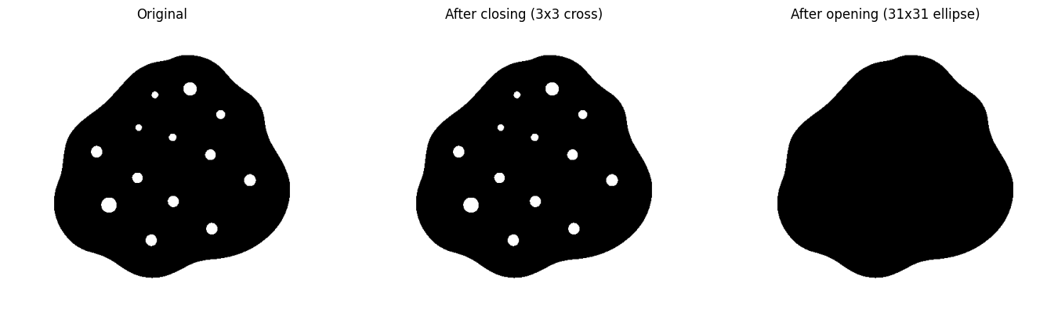

5. Fingerprint image (bright specks in the background and dark cracks in the ridges)
Code:-
closed, opened = clean_sequence(finger, rect3, rect3)
show([finger, closed, opened], ['Original', 'After closing (3x3)', 'After opening (3x3)'], size=(15, 4))

# Enlarged part of the images
show([finger[200:300, 100:250], closed[200:300, 100:250], opened[200:300, 100:250]],
['Original (enlarged)', 'After closing (enlarged)', 'After opening (enlarged)'], size=(15, 4))

Output:-
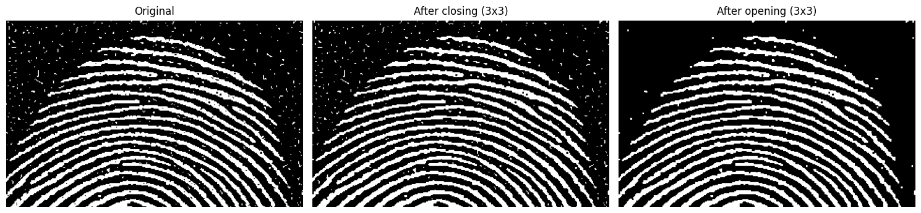
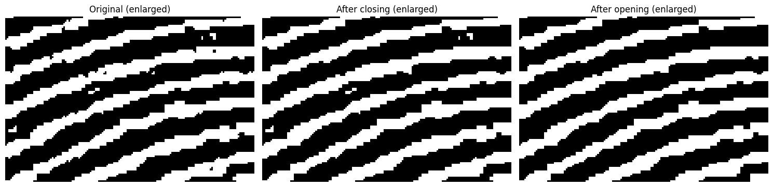

# Compare structuring elements and the order of operations on the fingerprint
def statistics(b):
n, l, st, _ = cv2.connectedComponentsWithStats(b, connectivity=8)
small = sum(1 for i in range(1, n) if st[i, cv2.CC_STAT_AREA] <= 30) # small bright specks
large = [st[i, cv2.CC_STAT_AREA] for i in range(1, n) if st[i, cv2.CC_STAT_AREA] > 100] # ridges
n2, l2, st2, _ = cv2.connectedComponentsWithStats(255 - b, connectivity=8)
cracks = sum(1 for i in range(1, n2) if st2[i, cv2.CC_STAT_AREA] <= 10) # small dark cracks
return small, len(large), sum(large), cracks

ellipse5 = cv2.getStructuringElement(cv2.MORPH_ELLIPSE, (5, 5))
op = lambda b, k: cv2.morphologyEx(b, cv2.MORPH_OPEN, k)
cl = lambda b, k: cv2.morphologyEx(b, cv2.MORPH_CLOSE, k)

methods = {
'Original': finger,
'Opening 3x3 only': op(finger, rect3),
'Closing 3x3 only': cl(finger, rect3),
'Closing -> Opening (3x3 square)': op(cl(finger, rect3), rect3),
'Closing -> Opening (3x3 cross)': op(cl(finger, cross3), cross3),
'Opening -> Closing (3x3 square)': cl(op(finger, rect3), rect3),
'Closing -> Opening (5x5 ellipse)': op(cl(finger, ellipse5), ellipse5),
}

print(f"{'Method':34s}{'Specks':>8s}{'Ridges':>8s}{'Ridge area':>12s}{'Cracks':>8s}")
for name, b in methods.items():
small, ridges, area, cracks = statistics(b)
print(f"{name:34s}{small:8d}{ridges:8d}{area:12d}{cracks:8d}")

Output:-
Method : Specks (small bright components), Ridges (large components), Ridge area (pixels), Cracks (small dark components)
Original : Specks 342, Ridges 23, Ridge area 59084, Cracks 41
Opening 3x3 only : Specks 30, Ridges 26, Ridge area 58390, Cracks 18
Closing 3x3 only : Specks 315, Ridges 23, Ridge area 60083, Cracks 0
Closing -> Opening (3x3 square) : Specks 35, Ridges 23, Ridge area 59581, Cracks 0
Closing -> Opening (3x3 cross) : Specks 91, Ridges 23, Ridge area 60615, Cracks 3
Opening -> Closing (3x3 square) : Specks 26, Ridges 23, Ridge area 59007, Cracks 0
Closing -> Opening (5x5 ellipse) : Specks 16, Ridges 28, Ridge area 60178, Cracks 0

6. Portrait image (not a binary image, so only an approximate result is possible)
Code:-
# Binary version : same sequence with 3x3 structuring elements
closed, opened = clean_sequence(portrait, rect3, rect3)

# The same sequence directly on the gray image (gray scale closing and opening)
gray_closed = cv2.morphologyEx(portrait_gray, cv2.MORPH_CLOSE, rect3)
gray_result = cv2.morphologyEx(gray_closed, cv2.MORPH_OPEN, rect3)

show([portrait_gray, portrait, closed, gray_result],
['Original (gray)', 'Binary (Otsu)', 'Binary after closing + opening', 'Gray image after closing + opening'], size=(18, 4))
print("Small bright specks (<= 30 pixels) : before =", statistics(portrait)[0], ", after =", statistics(opened)[0])

Output:-
Small bright specks (<= 30 pixels) : before = 1964 , after = 83
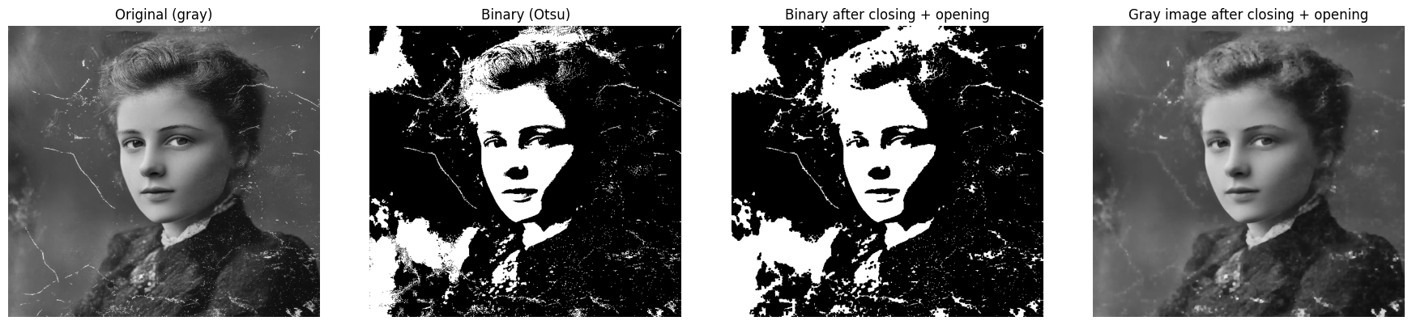

7. Controlled experiment (a clean image with known specks and cracks)
A clean ridge pattern similar to the fingerprint (ridge width 7, gap 11 pixels) is made. Bright specks (1 to 4 pixels) and dark cracks (1 to 2 pixels wide) are added, and the result of every sequence is compared with the clean image. The number of wrong pixels is averaged over 20 random noisy images.
Code:-
# Clean ridge pattern
clean = np.zeros((300, 300), np.uint8)
for r in range(30, 280, 18):
cv2.ellipse(clean, (150, 290), (r + 40, r), 0, 180, 360, 255, 7)

# Add 130 bright specks (1 to 4 pixels)
def add_specks(img, rng):
out = img.copy()
for _ in range(130):
x, y = rng.integers(5, 290, 2)
s = rng.choice([1, 2, 2, 2, 3, 4])
out[y:y + s, x:x + s] = 255
return out

# Add 40 dark cracks (1 to 2 pixels wide) across the ridges
def add_cracks(img, rng):
out = img.copy()
for _ in range(40):
x, y = rng.integers(20, 280, 2)
angle = rng.uniform(0, np.pi)
dx, dy = 10 * np.cos(angle), 10 * np.sin(angle)
cv2.line(out, (int(x - dx), int(y - dy)), (int(x + dx), int(y + dy)), 0, int(rng.integers(1, 3)))
return out

ellipse7 = cv2.getStructuringElement(cv2.MORPH_ELLIPSE, (7, 7))
sequences = {
'No filtering': lambda b: b,
'Opening 3x3 only': lambda b: op(b, rect3),
'Closing 3x3 only': lambda b: cl(b, rect3),
'Closing -> Opening (3x3 square)': lambda b: op(cl(b, rect3), rect3),
'Opening -> Closing (3x3 square)': lambda b: cl(op(b, rect3), rect3),
'Closing -> Opening (3x3 cross)': lambda b: op(cl(b, cross3), cross3),
'Closing -> Opening (5x5 ellipse)': lambda b: op(cl(b, ellipse5), ellipse5),
'Closing -> Opening (7x7 ellipse)': lambda b: op(cl(b, ellipse7), ellipse7),
}

# Number of wrong pixels compared with the clean image (average of 20 images)
def wrong(b):
return np.sum((b > 0) != (clean > 0))

results = {name: [[], [], []] for name in sequences}
for seed in range(20):
rng = np.random.default_rng(seed)
only_specks = add_specks(clean, rng)
only_cracks = add_cracks(clean, rng)
both = add_cracks(add_specks(clean, rng), rng)
for name, f in sequences.items():
results[name][0].append(wrong(f(only_specks)))
results[name][1].append(wrong(f(only_cracks)))
results[name][2].append(wrong(f(both)))

print(f"{'Method':34s}{'Specks only':>13s}{'Cracks only':>13s}{'Both':>10s}{'Both (%)':>10s}")
for name, r in results.items():
print(f"{name:34s}{np.mean(r[0]):13.0f}{np.mean(r[1]):13.0f}{np.mean(r[2]):10.0f}{100 * np.mean(r[2]) / clean.size:10.2f}")

# Example result (enlarged part of the image)
rng = np.random.default_rng(0)
noisy = add_cracks(add_specks(clean, rng), rng)
crop = (slice(120, 240), slice(60, 240))
show([clean[crop], noisy[crop], sequences['Closing -> Opening (3x3 square)'](noisy)[crop], sequences['Closing -> Opening (7x7 ellipse)'](noisy)[crop]],
['Clean image', 'Noisy image', 'Closing -> Opening (3x3 square)', 'Closing -> Opening (7x7 ellipse)'], size=(16, 4))

Output:-
Method : wrong pixels with specks only, wrong pixels with cracks only, wrong pixels with both, wrong pixels with both (%)
No filtering : Specks only 459, Cracks only 814, Both 1229, Both (%) 1.37
Opening 3x3 only : Specks only 349, Cracks only 1113, Both 1384, Both (%) 1.54
Closing 3x3 only : Specks only 616, Cracks only 517, Both 1063, Both (%) 1.18
Closing -> Opening (3x3 square) : Specks only 504, Cracks only 636, Both 1037, Both (%) 1.15
Opening -> Closing (3x3 square) : Specks only 430, Cracks only 960, Both 1273, Both (%) 1.41
Closing -> Opening (3x3 cross) : Specks only 422, Cracks only 773, Both 1128, Both (%) 1.25
Closing -> Opening (5x5 ellipse) : Specks only 525, Cracks only 276, Both 708, Both (%) 0.79
Closing -> Opening (7x7 ellipse) : Specks only 922, Cracks only 273, Both 1047, Both (%) 1.16
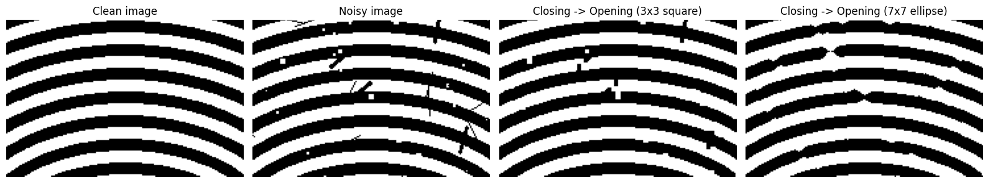

Observations:-
Measurements: The blob has 13 bright specks and the largest is 26 pixels wide. The fingerprint has ridges with a median width of 7 pixels, gaps between the ridges with a median width of 12 pixels, 342 small bright specks (mostly 2 pixels wide) and dark cracks which are 1 to 2 pixels wide.
Choice of structuring elements: The opening element must be larger than the specks and smaller than the thinnest part of the object. For the blob an ellipse of 31 x 31 is used (larger than the largest speck of 26 pixels, and a round shape suits the round specks); the blob itself is very large so its outline is not changed. For the fingerprint a 3 x 3 square is used for both closing and opening, because the specks and cracks are only 1 to 2 pixels wide, while the ridges (7 pixels) and the gaps (12 pixels) are much wider, so ridges are not removed and neighbouring ridges are not joined.
Blob image: All 13 specks are removed (3415 white pixels inside the object before, 0 after) and the match of the object shape with the true object (IoU) increases from 0.9683 to 1.0000, so the overall shape is fully preserved. The closing step has no effect here because this image has no cracks.
Fingerprint image: The number of small bright specks falls from 342 to 35, the small dark cracks fall from 41 to 0 and the number of ridges remains 23 (no ridge is broken or joined). The ridge area changes only from 59084 to 59581 pixels (+0.8 %). The specks which remain are 3 to 4 pixels wide solid blocks, which a 3 x 3 opening cannot remove.
Comparison of structuring elements (fingerprint): A 5 x 5 ellipse removes more specks (16 remain) but breaks the ridges into 28 pieces instead of 23, because some parts of the ridges are thinner than 5 pixels. A 3 x 3 cross is weaker (91 specks and 3 cracks remain). The 3 x 3 square keeps the ridges intact and was therefore chosen.
Order of operations: In the controlled experiment (specks and cracks together) closing followed by opening gives 1037 wrong pixels (1.15 %) while opening followed by closing gives 1273 wrong pixels (1.41 %), and doing nothing gives 1229 (1.37 %). Opening first removes slightly more specks (430 wrong pixels against 504 with specks only), but it erodes the corners of the ridges at the ends of the cracks and the closing cannot restore them (960 wrong pixels against 636 with cracks only). Opening alone is worse than no filtering (1384 against 1229). So closing is done first and opening second. On the real fingerprint both orders fill all the cracks and keep 23 ridges, and opening first leaves fewer specks (26 against 35), so the difference is small there.
Portrait image: This is a photograph and not a binary image, so it was converted with Otsu thresholding. The same sequence (3 x 3 closing and opening) reduces the small bright components from 1964 to 83, and the thin scratches are removed while the face and the shape of the hair are kept. When the sequence is applied on the gray image the thin scratches are reduced and the face stays natural, but the wider scratches remain.
Failure cases: (1) Specks bigger than the opening element remain (35 specks of 3 to 4 pixels in the fingerprint). (2) Cracks wider than the closing element are not filled. (3) Elements which are too large damage the object: the 7 x 7 ellipse breaks the ridges in the controlled experiment and the 5 x 5 ellipse breaks the real ridges. (4) Closing joins objects which are closer than the size of the element.

Conclusion
Closing followed by opening, with structuring elements chosen from the measured sizes of the specks, cracks and objects, removes the small bright noise and fills the narrow dark cracks while keeping the overall shape. The element must be larger than the noise (specks or cracks) and smaller than the finest detail of the object: a 31 x 31 ellipse for the blob and a 3 x 3 square for the fingerprint. Closing should be done first, because opening first damages the object near the cracks. Noise which is larger than the element cannot be removed without damaging the object.

